Disposition of Data

FIRESIDE CHAT FEATURING Doug Branch

# Data Usage

MX and Engineering analysis usage: 30.A.5.d

Page 30-1

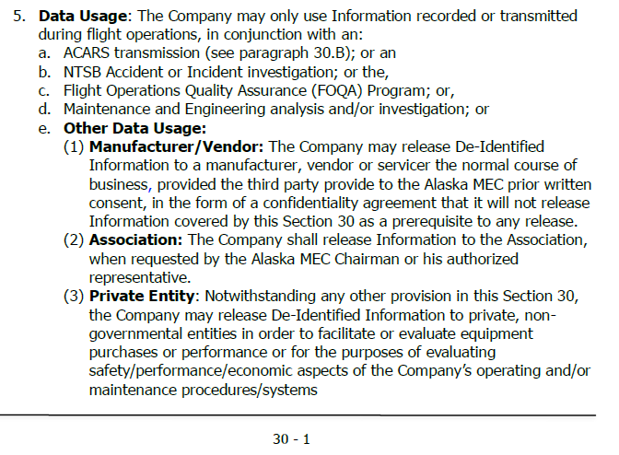

# DISPOSITION OF DATA

Disposition Data 30.A.6

Page 30-2

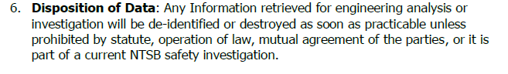

Engine data is allowed

Record Number: 90 day period will allow gatekeeper to identify the crew using ID

MX/TECH SRV does not have to delete the data they just have to delete the flight number and/or date-time

Identifiable information:

Date-time

Flight Number

City Pairs where there are few number of flights a day

Objective: To avoid a database of information outside of FOQA

Two ways to dispose of data:

1. Deidentify the data
2. Destroy everything

**ACTION ITEM- DOUG**: Do we care about destruction of data if it’s been deidentified?

**ACTION ITEM- DOUG**: Is # 5 identifiable

1. LEAP-1A/1B Engine Electronic Control (EEC) Download
   1. Continuous Engine Operating Data (CEOD)
   2. Diagnostics Trend Data Manual download

**ACTION ITEM- DOUG**: Who should be included in the disposition confirmation emails?

Form process envisioning

1. Form submitted
2. 1,2,4
3. After they get their identified data
4. Reminder at **90?** days (email until they submit the request)

Email sent to: Alvin, Bjorn and the requestor

1. Provide a list of things that make the data identifiable



1. Checklist: Has the data been deidentified or destroyed?
   1. Save record confirming the destroying of data
2. After the person acknowledges that they destroyed the data Alvin/Bjorn get an email